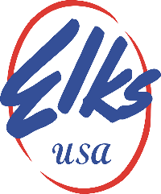

Robert D. Pagnani March 17, 2020
Special Deputy GER, Utah
pagnanir@gmail.com

Subject: Recommendations for Utah Elks Lodges during Coronavirus.

Dear Utah Elks Association Officers, Members and Lodges,

The UEA President and I have received several calls concerning the Coronavirus. The following are suggestions on what you should do for your lodge until April 1, 2020 when the situation can be re-evaluated. We know that many of you are looking forward to enjoying upcoming lodge activities and events, however, of necessity; it is... understood that there will be a need for some closures, cancellations and/or postponements. Please advise your District Deputy if you decide to cancel a Lodge Meeting or close the lodge.

- Follow guideline for protection and sanitation as put out by CDC.
- Installation of officers should be rescheduled, you have until April 15, or limited to incoming and out going officers only. The ceremony should be kept in accordance with statues and no celebrations afterwards.
- All activities ( food services,bingo,pool tournaments,etc..) should be cancelled until further notice.
- Social quarters should be limited to 10 members in an area or less and no guest allowed.

If we remain calm , monitor ever situation and follow the guidelines of state and local health officials we will get through this. Remember check on family,friends and especially the elderly.
Remember, if you fail to follow directives as disclosed by the CDC , the possibility of facing a court challenge should anyone claim they contacted the virus from your lodge could be costly.

If you have question please feel free to contact UEA State President Hortt Carter or myself.

Robert D. Pagnani
Special Deputy GER, Utah
435-830-1599

Hortt “ Allen” Carter
UEA State President
435-313-6841

A Fraternal Organization

