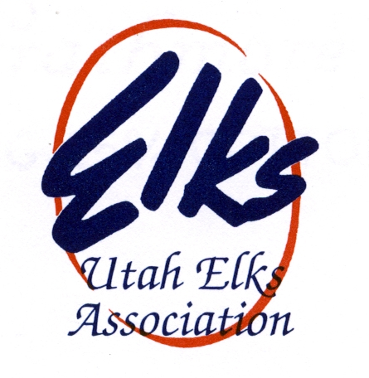
4-11-2020
Dear UEA Members,

I hope this finds you all healthy and happy. I write this with thanks for the support you have given to me and our association. We are experiencing something we’ve never dealt with and times are challenging.
With that being said, after much deliberation and many phone calls, it has been recommended that our Utah Elks Association stay as it is now until our state convention in May of 2021. I am asking all officers and committee chairs to remain in your positions. The reason for this is so our incoming president be given the opportunity to attend out of state conventions. President-elect Jared would not be able to travel due to the closures of California, Arizona and Nevada’s conventions. He has worked hard for this position and it’s only fair and reasonable that he gets the opportunity to attend these functions.
As of today, there is no word if Grand Lodge will be held or not. Hopefully by mid-May we will have an answer. Until then, lodges will remain closed until the restrictions have been lifted. I know that bills have to be paid. The lodge secretary and treasurer will take care of this. If a situation arises that needs immediate attention, lodge trustees will be contacted by phone and email. And once again, please, no meetings at the lodge.
I’m sorry for the inconvenience this has caused you and your lodges. We will get through this stronger than ever. If you have any questions or concerns, please feel free to call me at 435-313-6841 or email at horttc@yahoo.com.

Fraternally,

Hortt Carter
UEA President 2019-2020

Robert Pagnani
SDGER

