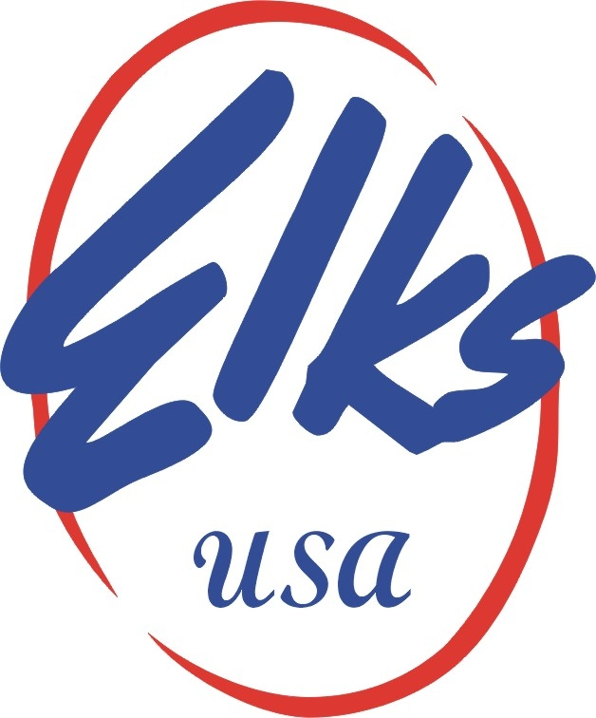
FAX: (773) 755-4905 PHONE: (773) 755-4904
Email: RickG@elks.org

MEMBERSHIP/PUBLIC RELATIONS
-
Rick Gathen A Fraternal Organization 2750 N. Lakeview Avenue
Manager Chicago, IL 60614-1889

MEMORANDUM

DATE: October 2012

TO: All Eligible Local Elks Lodges

MEDIA ALERT – FOR IMMEDIATE RELEASE

154th Anniversary of the Benevolent and Protective Order of Elks

ELKS WERE FOUNDED ON FEBRUARY 16, 1868

Chicago, IL – Local Elks Lodges throughout the United States, Guam, Puerto Rico, the Philippines, and the Panama Canal will be celebrating 154 years of community service on February 16, 2022.
The Benevolent and Protective Order of Elks has made more than 12 Billion in donations since we first started 154 years ago. Last year alone, the Elks donated approximately $375 million in cash, gifts and time to make our communities better places to live. The Elks are one of the premier patriotic and charitable organizations in the United States of America.
Elk volunteers will visit thousands of hospitalized Veterans that have protected our freedoms. The Elks vow “So long as there are Veterans, the Benevolent and Protective Order of Elks will never forget them.” The Elks support both active military forces and retired veterans. Elks furnish food, comfort care items, therapeutic items, provide gifts, host holiday celebrations, and recreational activities at bases and hospitals and stand ready to fulfill any need when called upon. Last year alone, the value of Elks’ contributions to the nation’s heroes provided more than $50 million to more than 300 Veterans Administration Medical Centers, clinics, and state care facilities.
Annually, the Elks award college scholarships across the nation totaling more than $4.5 million.
The Elks Community Investment Program will award nearly $47 million towards enriching our communities.
There are nearly 1,800 Elks Lodges across the country with a total membership of around 800,000. Elk’s members must be American citizens who are at least 21 years of age and must believe in God. To learn more and to join us in service, visit www.elks.org. For membership information visit Join.Elks.Org.

